***SCREEN SHOTS***

**Homepage**

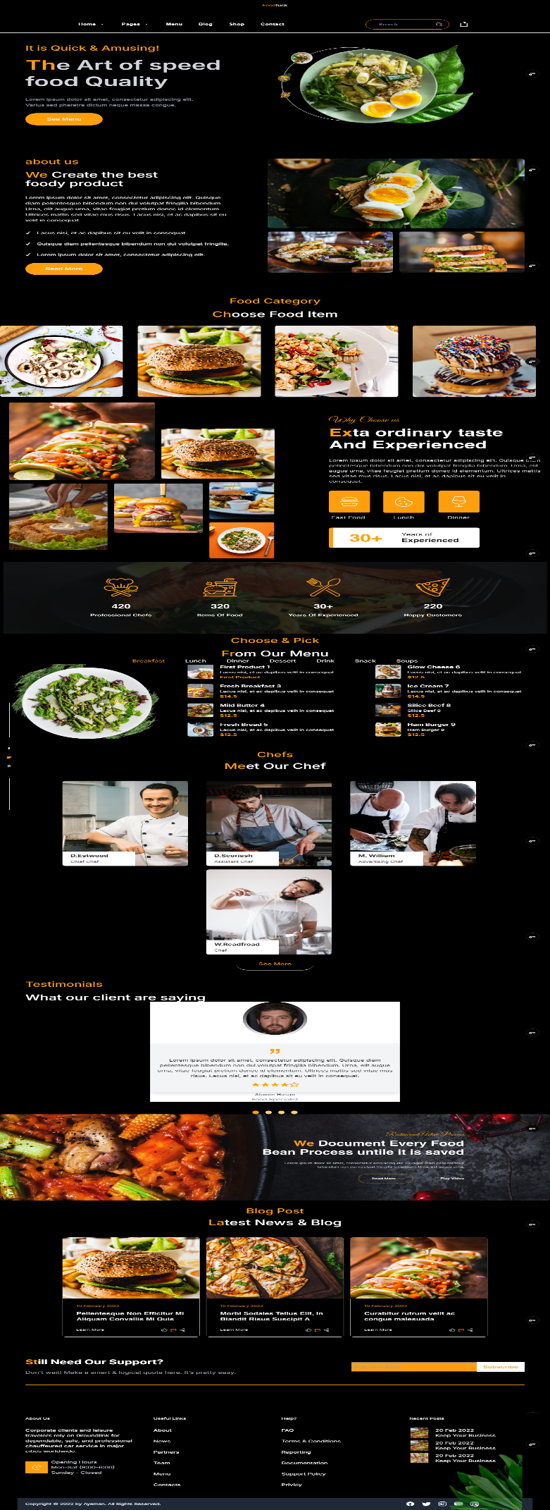

**About Us**

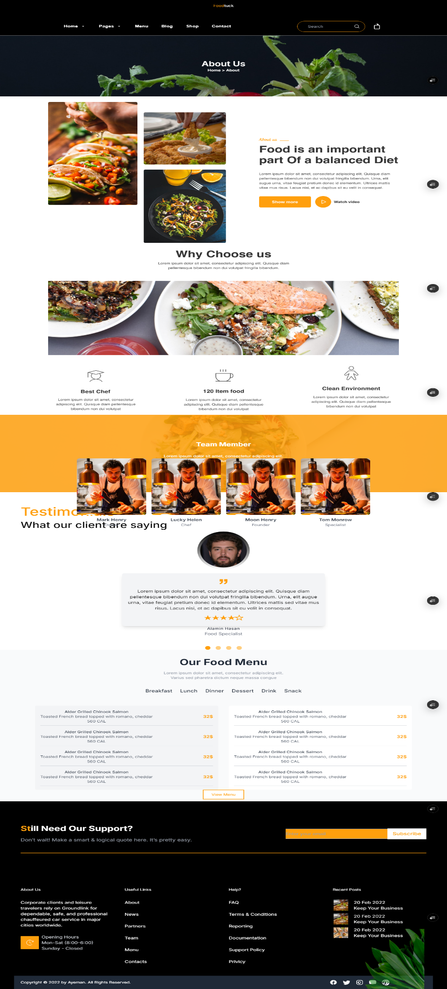

**Menu**

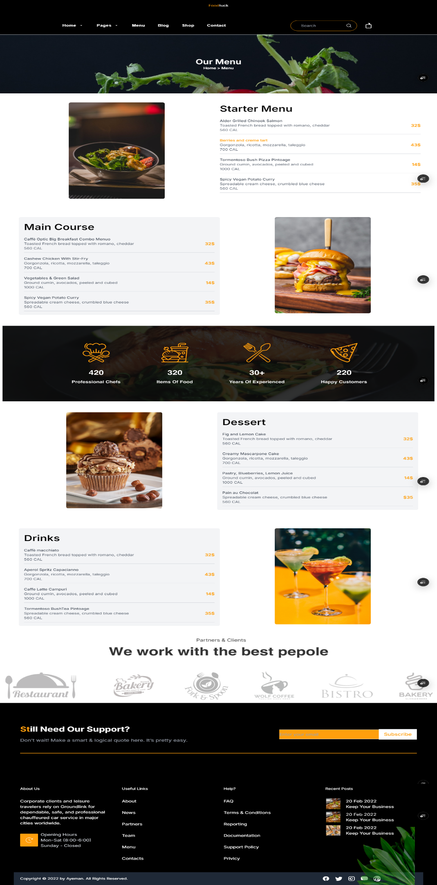

**Blog Page**

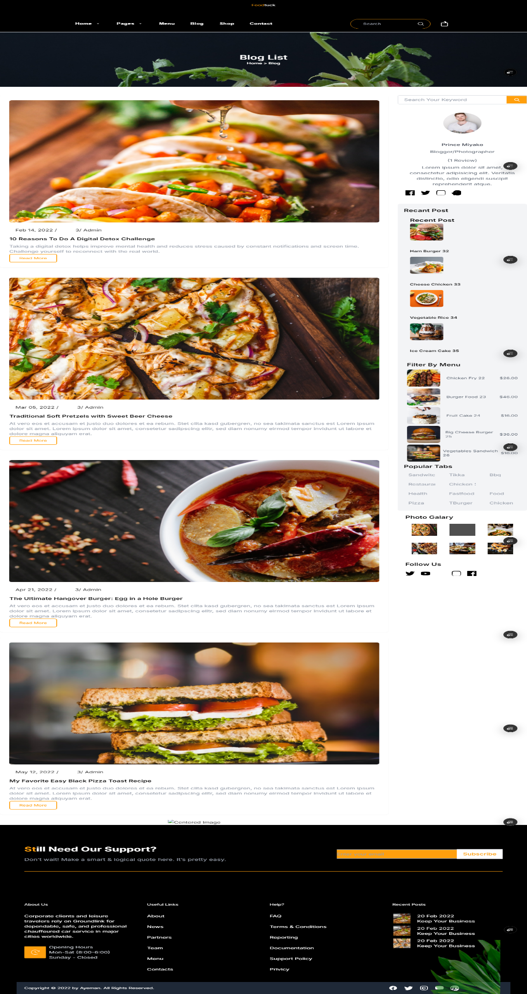

**Blog Detail**

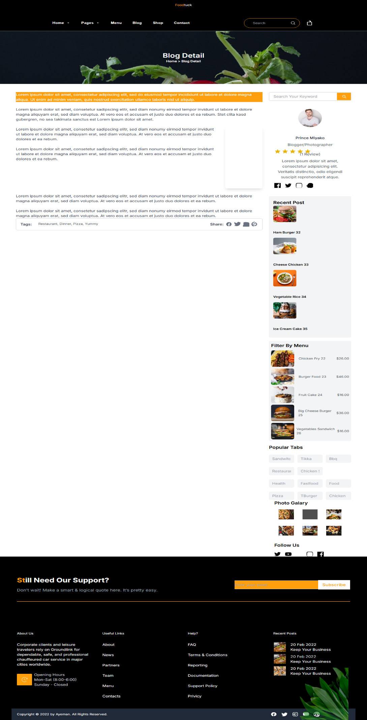

**Our Chefs**

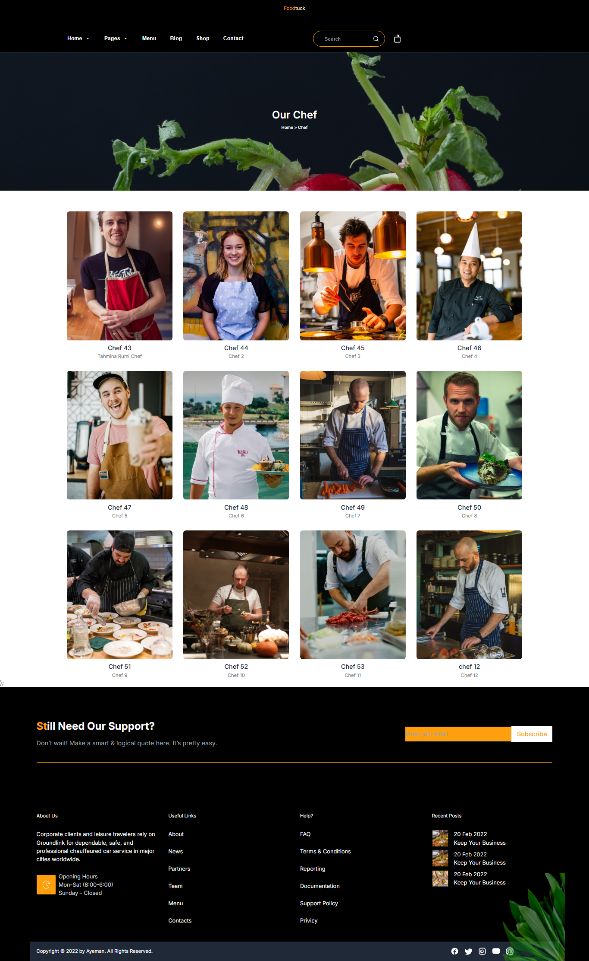

**Cheekout**

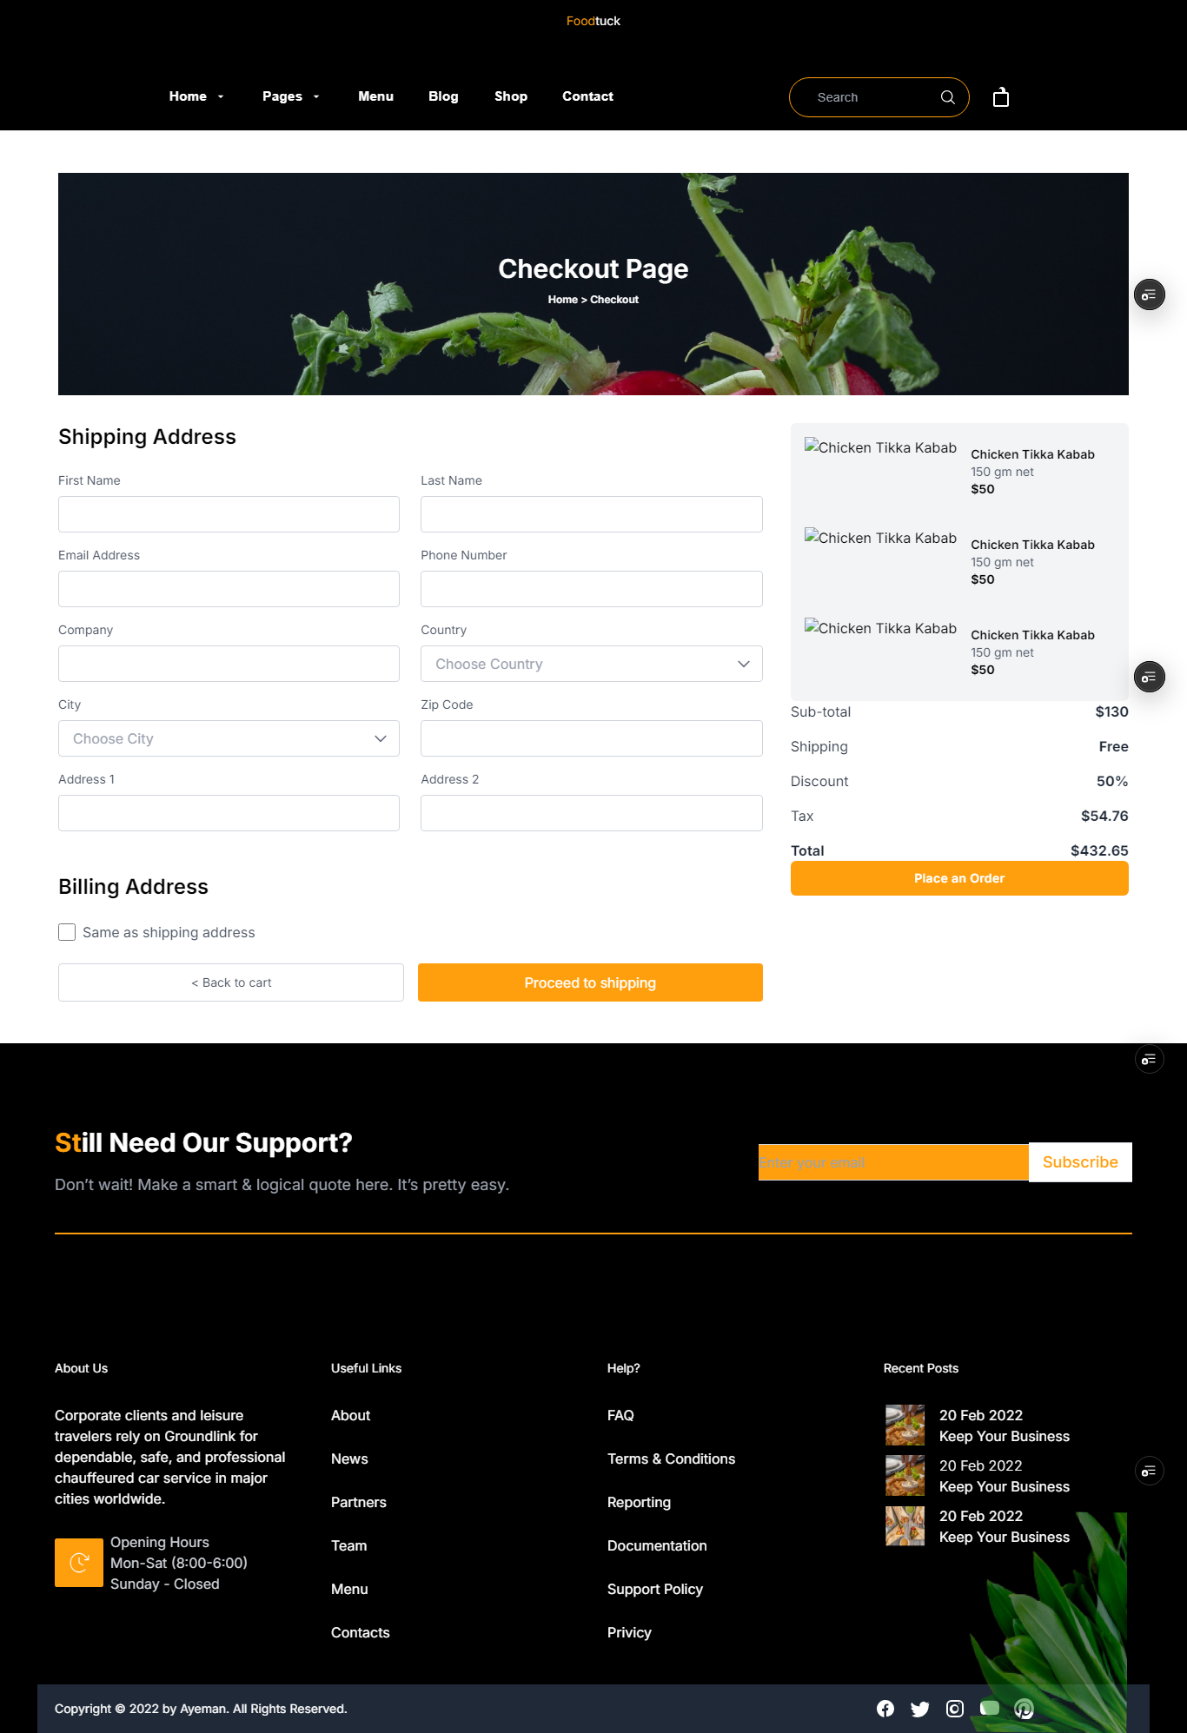

**FAQPage**

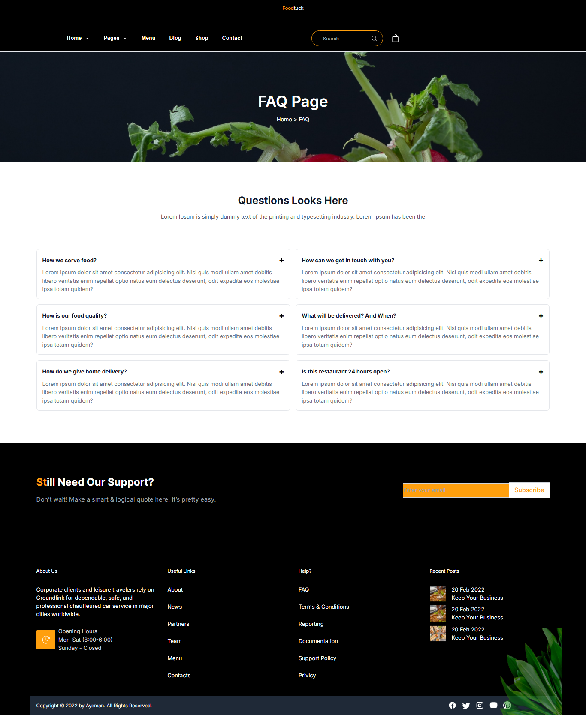

**Shop List**

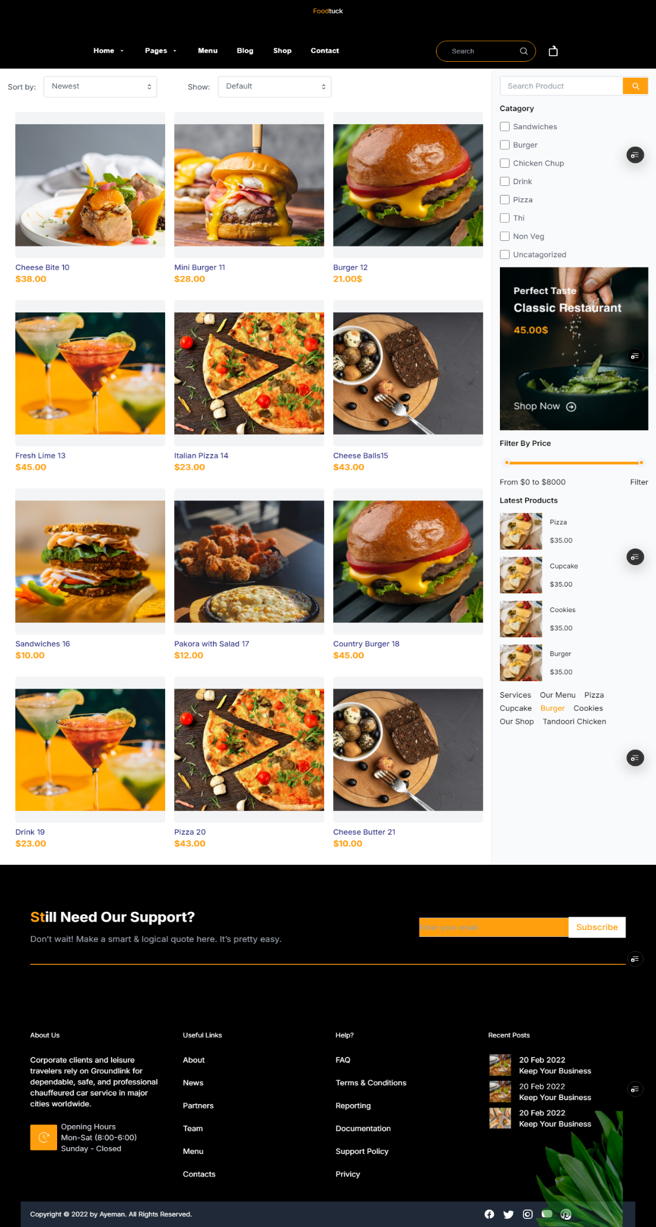

**Shop Detail**

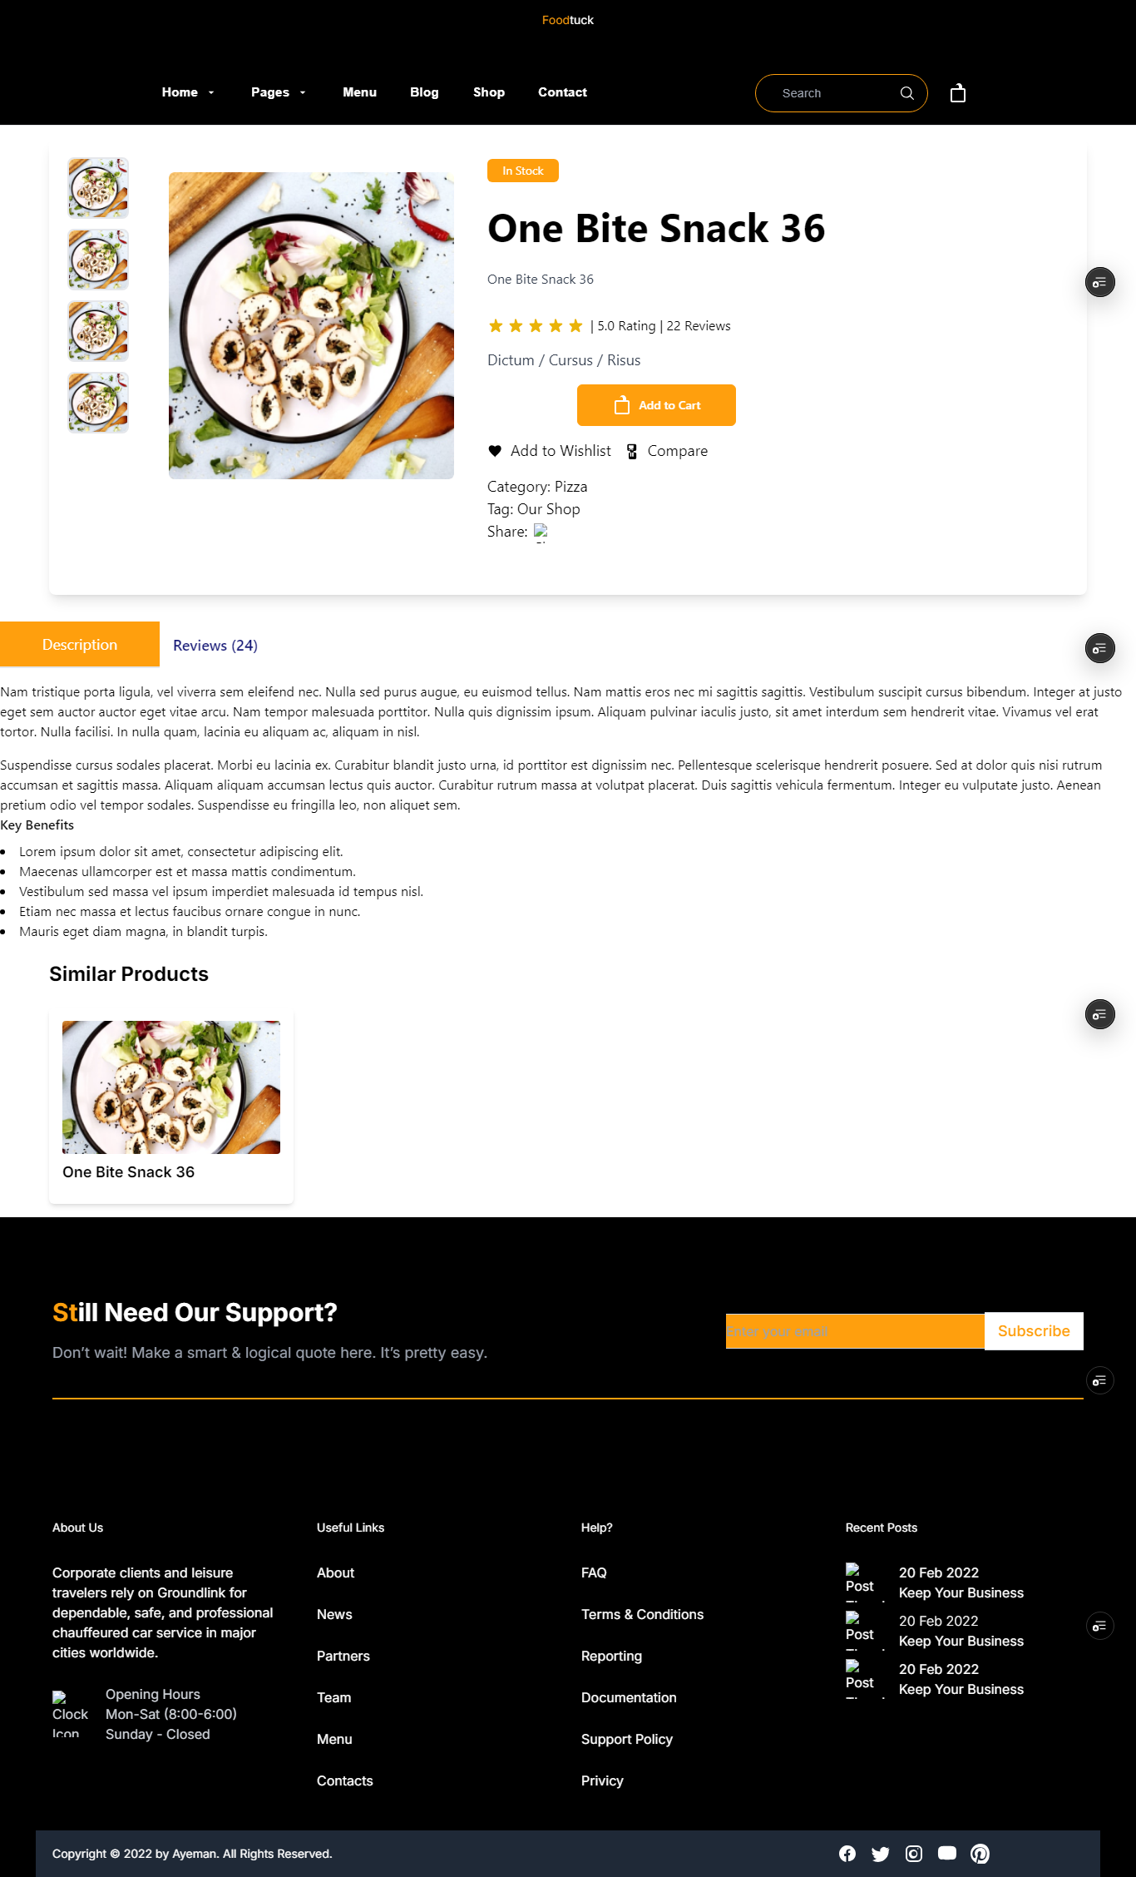

**Shopping cart**

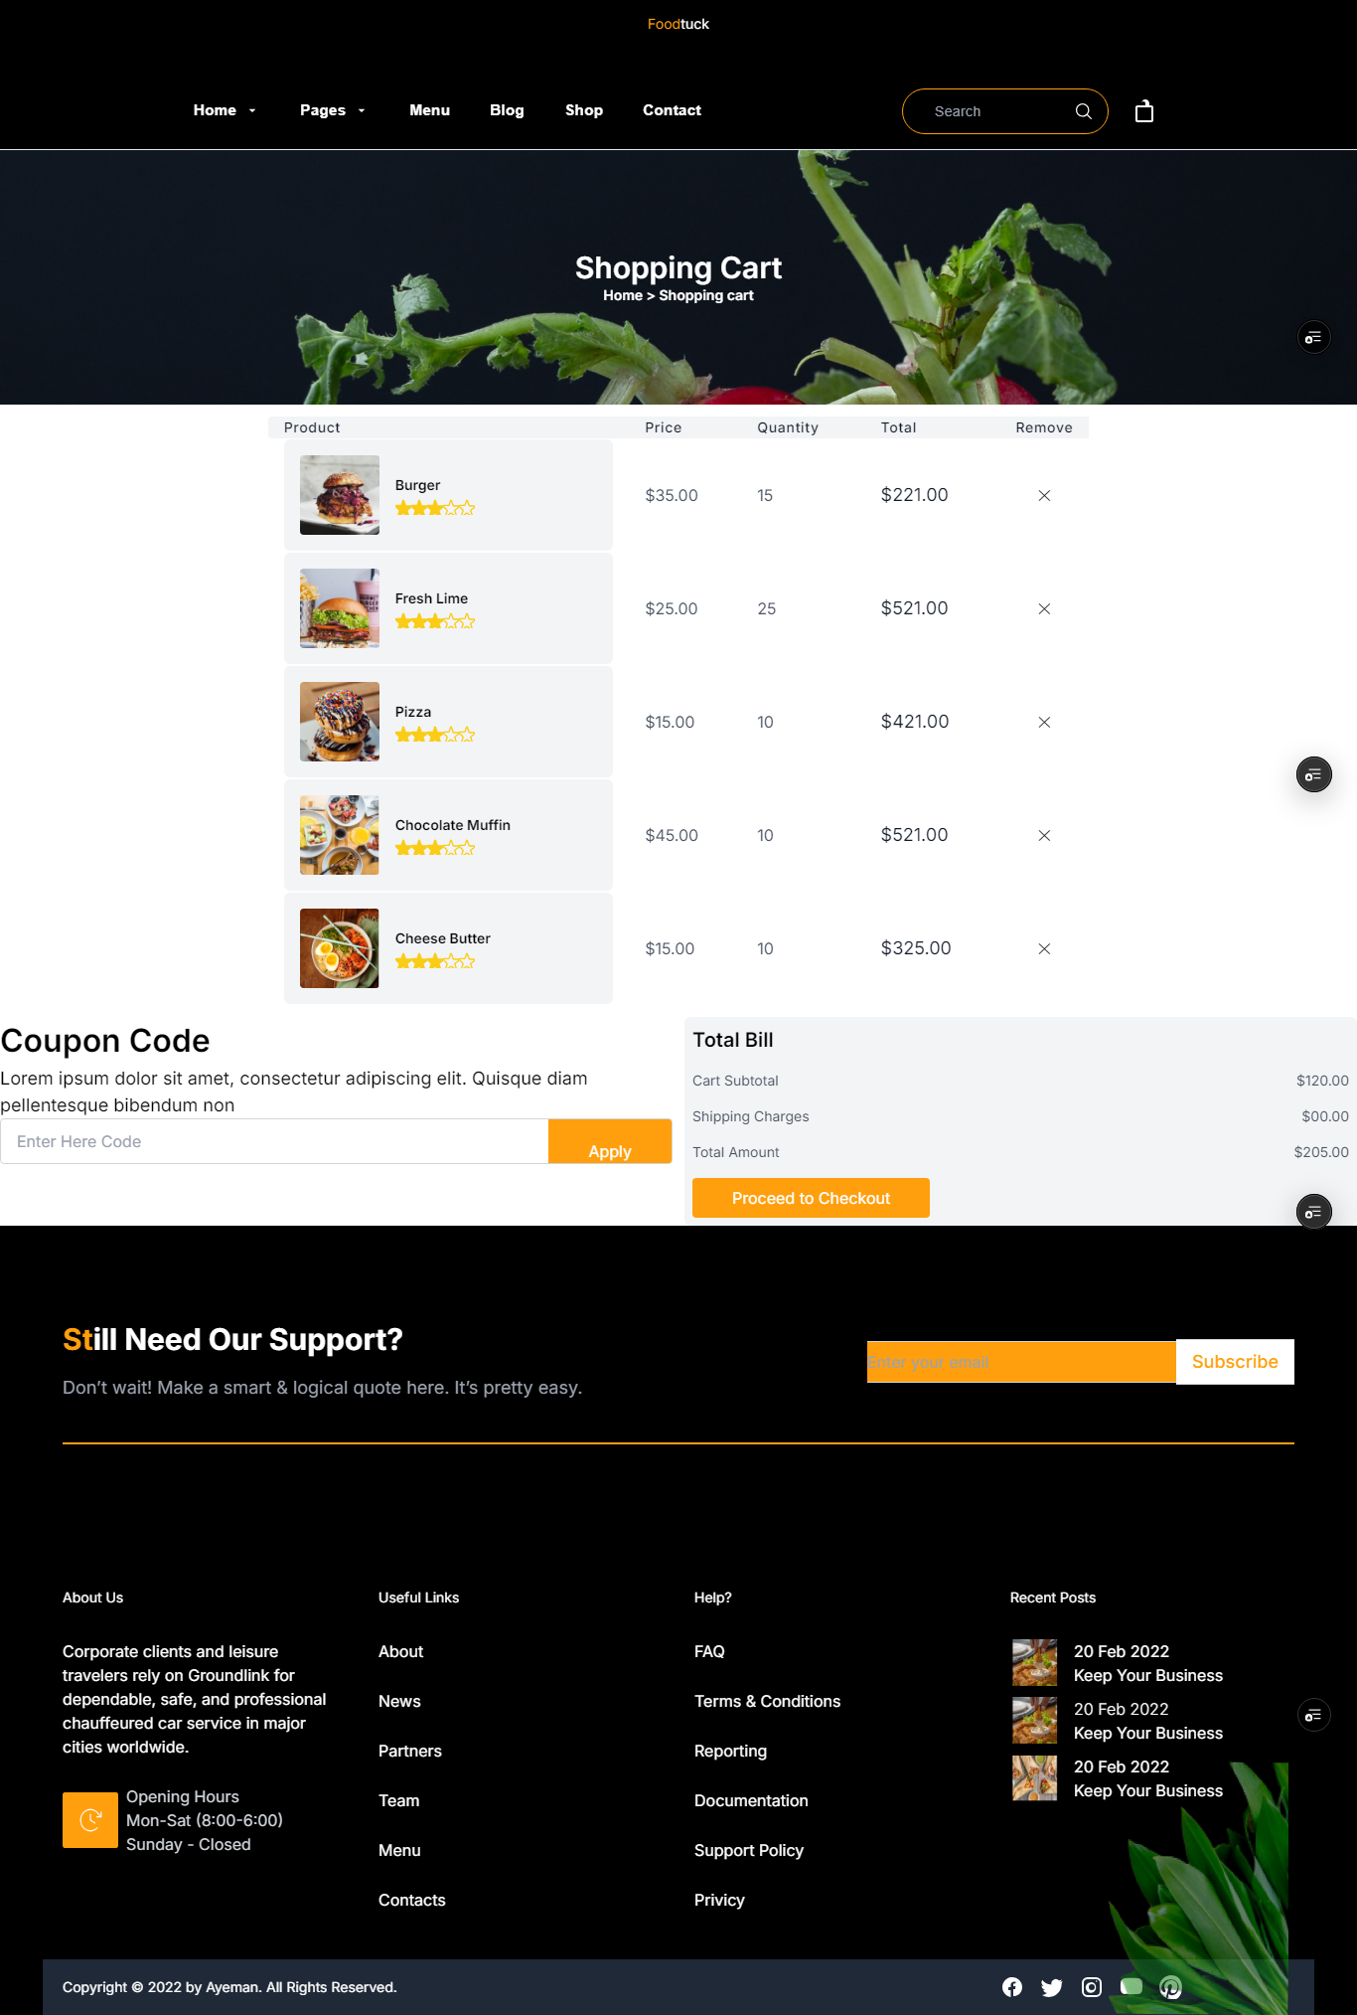

**404 Page**

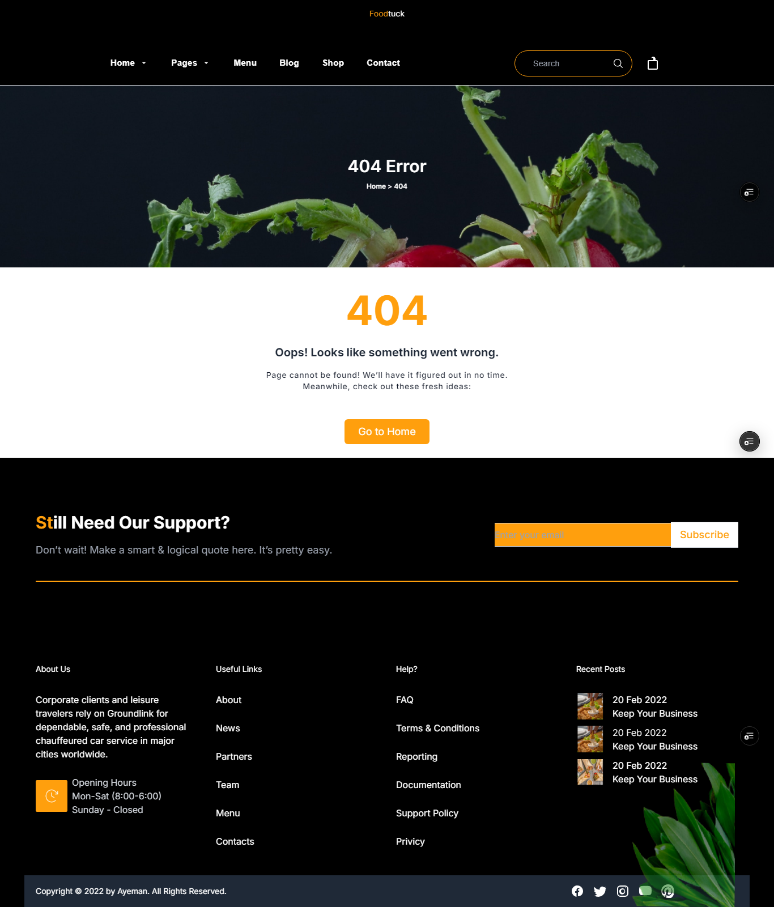

**Sign In**

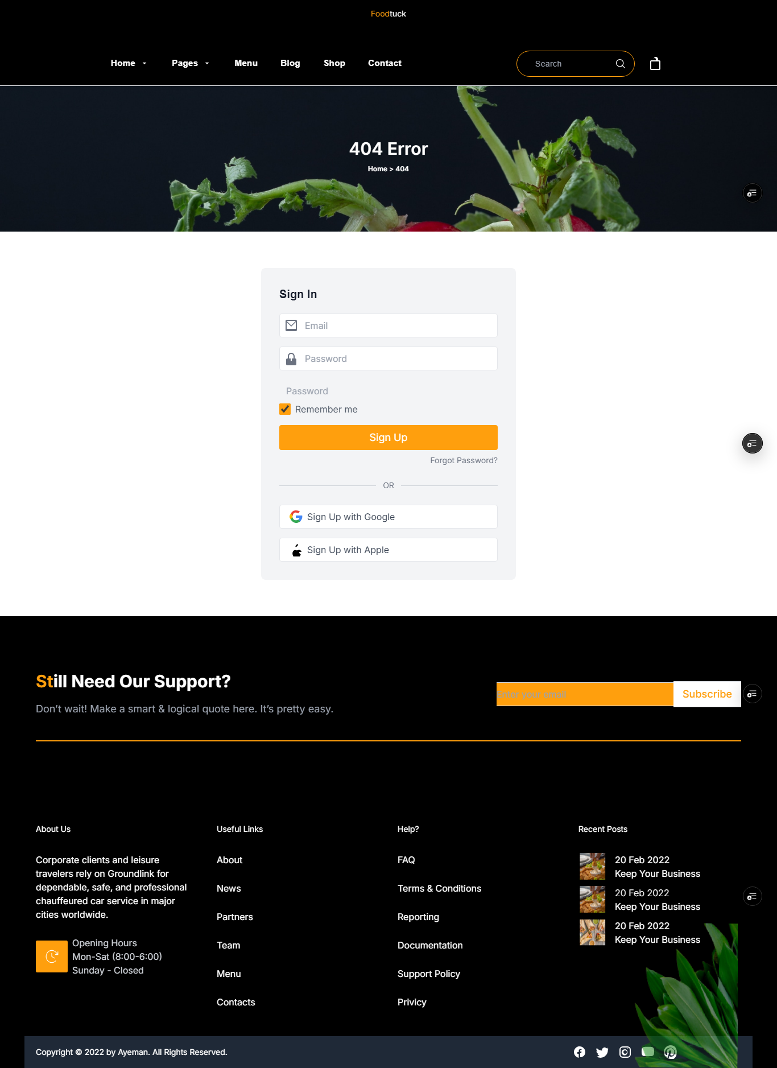

**Sign Up**

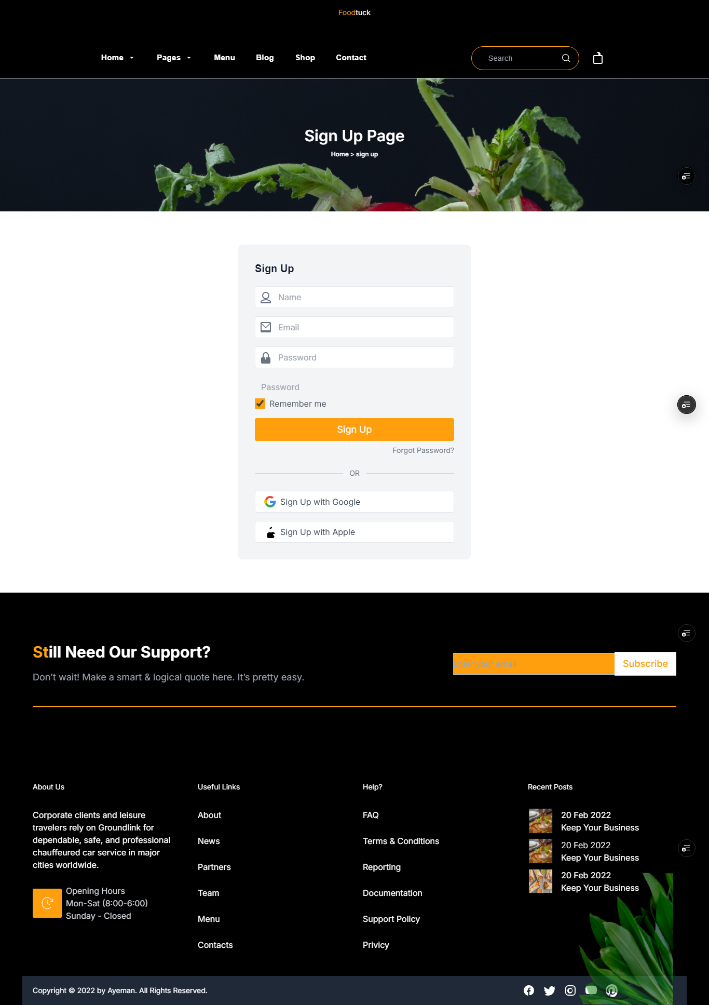

**Checklist for Day 5:**

Functional Testing: ✔

Error Handling: ✔

Performance Optimization: ✔

Cross-Browser and Device Testing: ✔

Security Testing: ✔

Documentation: ✔

Final Review: ✔